

School of Computer Science Engineering and Information Systems

Fall Semester 2026-2027

Department of Computer Applications

PMCA698J – Dissertation -I

Review -1

Date: 14.8.2026
An Explainable AI-Driven Framework for Toxic Content Detection and Intelligent Content Moderation

25MCA0004 – Tamizhini R
Under the Guidance of
Ramesh P S
Associate Professor Grade 2
SCORE

Guide Signature with date

Internal Examiner -1 Internal Examiner-2
Signature Signature
ABSTRACT:

The rapid growth of social media has increased toxic communication, harassment, threats, insults, and other harmful interactions, creating challenges for effective content moderation. Conventional toxicity detection systems mainly classify individual messages as toxic or non-toxic and often overlook conversational context, repeated harassment, user behavior, multilingual communication, and prediction uncertainty. This project proposes an Explainable AI-Driven Framework for Toxic Content Detection and Intelligent Content Moderation for real-time protection in an Instagram-like social media environment. The system intercepts comments and direct messages before delivery and performs language detection, multilingual and code-mixed text processing, multi-label toxicity classification, context analysis, behavioral risk profiling, harassment detection, uncertainty estimation, and explainable AI. XLM-RoBERTa with LoRA/PEFT is proposed for classifying toxic, severe-toxic, obscene, threat, insult, and identity-hate content. A transparent Risk Engine combines toxicity, severity, confidence, historical violations, behavioral patterns, context, and escalation indicators to generate an adaptive risk score. Based on risk levels, the system can allow, warn, quarantine, restrict, temporarily block, or forward content for human review. Explainable predictions provide important words and reasons behind decisions. The framework aims to provide proactive, transparent, adaptive, and human-assisted moderation while improving user safety and reducing dependence on simple message-level classification.

Keywords: Explainable AI, Toxic Content Detection, Intelligent Content Moderation, XLM-RoBERTa, LoRA, Multilingual NLP, Code-Mixed Text, Risk Assessment, Harassment Detection, Adaptive Moderation.

INTRODUCTION:

Social media platforms have become an important medium for information sharing, and interaction among users. However, the increasing volume of user-generated content has also resulted in the rapid spread of toxic comments, insults, threats, harassment, obscene language, and identity-based abuse. Such harmful interactions can negatively affect user safety and create challenges for conventional content moderation systems. Existing toxicity detection approaches generally focus on classifying an individual message as toxic or non-toxic, which may not be sufficient for understanding the actual risk associated with an interaction.
This project, An Explainable AI-Driven Framework for Toxic Content Detection and Intelligent Content Moderation, proposes a proactive approach that goes beyond simple toxicity classification. The system analyzes comments and direct messages before they are delivered and considers multiple factors, including toxicity level, threat probability, severity, conversation context, previous violations, repeated interactions, behavioral patterns, and prediction uncertainty.
The proposed framework uses multilingual and code-mixed text processing to support diverse user communication. An advanced XLM-RoBERTa with LoRA/PEFT model is proposed for multi-label classification of toxic, severe-toxic, obscene, threat, insult, and identity-hate content.
A major feature of the project is Explainable AI (XAI), which provides understandable reasons behind moderation predictions. The system also incorporates a Risk Engine that combines different risk factors to generate a transparent risk score. Based on this score, content can be allowed, warned, quarantined, restricted, temporarily blocked, or forwarded for human review.
Thus, the proposed framework aims to provide proactive, explainable, adaptive, and intelligent content moderation, improving user safety while reducing the limitations of isolated message-level toxicity detection.

PROBLEM STATEMENT:
- Social media platforms are experiencing an increasing amount of toxic comments, insults, threats, harassment, obscene content, and identity-based abuse.
- Existing toxicity detection systems mainly classify individual content as toxic or non-toxic, which is insufficient for complex online interactions.
- Current approaches may fail to consider conversation context, repeated harmful messages, user behavior, and harassment escalation.
- Multilingual and code-mixed content creates additional challenges for accurate toxicity detection.
- A single toxic message does not always represent the same level of risk; therefore, moderation requires severity and risk assessment.
- AI predictions may contain uncertainty, but conventional systems may make moderation decisions without properly considering confidence and uncertainty.
- Many automated moderation systems provide limited information about why a particular message was flagged, reducing transparency and user trust.
- There is a need to distinguish between different harmful categories such as toxic, severe-toxic, obscene, threat, insult, and identity-hate content.
- A simple classification system cannot determine the most appropriate response, such as warning, quarantining, restricting, blocking, or human review.
- Therefore, the project aims to develop an Explainable AI-Driven Framework that combines toxicity detection, context analysis, behavioral risk assessment, explainability, uncertainty estimation, and intelligent adaptive content moderation to provide safer social media interactions.

OBJECTIVES:
- To develop an Explainable AI-driven framework for detecting and classifying toxic social media content.
- To implement multi-label toxicity detection for toxic, severe-toxic, obscene, threat, insult, and identity-hate content.
- To develop a multilingual and code-mixed text processing module supporting English, Tamil, Hindi, Malayalam, Telugu, and Kannada.
- To analyze conversation context rather than relying only on the current message.
- To identify repeated harassment and escalation patterns using message frequency, severity, timing, and conversation history.
- To develop a behavioral risk profiling mechanism based on previous violations, warnings, threats, repeated targeting, and user behavior.
- To implement a Risk Engine that combines toxicity, severity, confidence, context, behavioral history, and escalation factors to calculate an overall risk score.
- To incorporate confidence and uncertainty estimation so that low-confidence predictions can be forwarded for human review instead of causing inappropriate automatic actions.
- To provide Explainable AI by identifying important words/tokens and generating understandable reasons for moderation decisions.
- To implement intelligent and adaptive moderation actions, including allow, warn, quarantine, restrict, temporary block, and human review based on risk level.
- To evaluate the framework against adversarial and obfuscated toxic content and measure its robustness.
- To provide a human-in-the-loop moderation system that allows moderators to review AI decisions and provide feedback for future model improvement.

SCOPE OF THE PROJECT:
The scope of the project is to develop an Explainable AI-Driven Framework for Toxic Content Detection and Intelligent Content Moderation for an Instagram-like social media environment. The system focuses on detecting toxic, severe-toxic, obscene, threatening, insulting, and identity-hate content from comments and direct messages using AI-based multi-label classification. It supports multilingual and code-mixed text processing and considers conversation context, repeated interactions, user behavior, harassment, and escalation patterns rather than analyzing only individual messages. The framework generates a transparent risk score by combining toxicity, severity, confidence, historical violations, behavioral patterns, and contextual information. Based on the identified risk level, the system can allow, warn, quarantine, restrict, temporarily block, or forward content for human review. It also provides explainable predictions by identifying important words and reasons behind AI decisions, along with uncertainty estimation for handling low-confidence predictions. A moderator dashboard supports human review and feedback collection for future model improvement. The system further includes real-time notifications, blocking and restriction features, security controls, audit logging, model evaluation, and adversarial robustness testing.

PROPOSED SYSTEM:
The proposed system is an Explainable AI-Driven Framework for Toxic Content Detection and Intelligent Content Moderation designed for an Instagram-like social media platform. The system analyzes comments and direct messages in real time before they are delivered to the recipient. It combines multilingual and code-mixed text processing, multi-label toxicity detection, conversation-context analysis, behavioral risk profiling, harassment and escalation detection, confidence and uncertainty estimation, and Explainable AI.

The proposed framework uses XLM-RoBERTa with LoRA/PEFT for advanced multi-label classification of toxic, severe-toxic, obscene, threat, insult, and identity-hate content. A separate Risk Engine combines the current message's toxicity and severity with model confidence, conversation context, previous violations, repeated interactions, and behavioral patterns to calculate an overall risk score.

Based on the calculated risk and configured policies, the Intelligent Moderation Engine selects an appropriate action such as Allow, Warn, Quarantine, Restrict, Temporary Block, or Human Review instead of using a simple toxic/non-toxic decision. For uncertain predictions, the system can involve human moderators to avoid inappropriate automated actions.
The system also provides Explainable AI by identifying important words or tokens and generating understandable reasons for moderation decisions. A moderator dashboard allows administrators to review flagged content, approve or reject decisions, apply restrictions, and provide feedback for future model improvement.
Overall, the proposed system aims to provide proactive, explainable, context-aware, risk-based, and adaptive content moderation, thereby improving user safety while overcoming the limitations of conventional message-level toxicity detection.

LITERATURE SURVEY:

S.NO | TITLE | MERITS | DEMERITS
1 | Automated Hate Speech Detection and the Problem of Offensive Language | The study distinguishes hate speech from general offensive language using a multi-class classification approach. It shows that simple keyword-based detection can produce false positives and highlights the importance of differentiating harmful categories. | The study mainly focuses on Twitter data and traditional classification approaches. It does not address multilingual content, conversational context, explainability, or adaptive moderation.
2 | A Study of Multilingual Toxic Text Detection Approaches under Imbalanced Sample Distribution | The study addresses multilingual toxicity detection and class imbalance. It uses multilingual BERT and XLM-RoBERTa to capture semantic and contextual information, making it highly relevant to multilingual toxic-content detection. | The work mainly concentrates on classification performance and dataset imbalance. It does not provide a complete moderation framework involving behavioral risk, human review, or adaptive moderation.
3 | Toxicity Detection for Indic Multilingual Social Media Content | The research focuses on low-resource Indic languages and code-mixed/code-switched social-media content. An ensemble of XLM-RoBERTa and MuRIL demonstrated strong performance, showing the importance of multilingual transformer models for Indian social media. | The approach mainly focuses on toxicity classification and does not incorporate explainable AI, conversation-level analysis, user behavioral risk, or intelligent moderation decisions.
4 | An Automated Toxicity Classification on Social Media Using LSTM and Word Embedding | The study investigates LSTM-based toxicity classification using GloVe and BERT-based embeddings. It considers multiple toxicity categories such as toxic, obscene, insult, identity hate, severe toxic, and threat. | LSTM-based approaches have limitations compared with modern multilingual transformer models. The work does not provide context-aware moderation, explainability, uncertainty handling, or adaptive user-level actions.
5 | HateXplain: A Benchmark Dataset for Explainable Hate Speech Detection | The study introduces a benchmark dataset containing hate, offensive, and normal categories along with target communities and human rationales. It demonstrates that high classification performance does not necessarily guarantee good explainability. | The work primarily provides a dataset and explainability benchmark rather than a complete real-time moderation system. It does not address behavioral risk or adaptive moderation actions.
6 | Multi-task Learning for Toxic Comment Classification and Rationale Extraction | The study combines toxic-comment classification with rationale extraction, supporting the idea that identifying the specific portions responsible for toxicity can improve moderation transparency. | Rationale extraction is mainly focused on the text itself and does not incorporate user history, repeated harassment, risk scoring, or real-time adaptive moderation.
7 | Detecting Unintended Social Bias in Toxic Language Datasets | The research investigates unintended social bias in toxicity datasets and considers gender, race/ethnicity, religion, political, and related bias. It emphasizes the importance of fairness when developing toxicity detection systems.. | The work focuses primarily on dataset bias and bias identification rather than complete content moderation. It does not provide context-aware risk assessment or moderation workflows.
8 | ToxiSpanSE: An Explainable Toxicity Detection in Code Review Comments | The proposed system identifies specific toxic spans instead of simply assigning a toxic/non-toxic label. Highlighting toxic spans helps moderators understand the reason behind a classification and improves interpretability. | The research is specifically designed for software-engineering code-review comments, so its domain is narrower than general social-media communication. It does not address multilingual or behavioral moderation.
9. | Rule By Example: Harnessing Logical Rules for Explainable Hate Speech Detection | The method combines machine learning with logical rules to produce rule-grounded and customizable predictions. It improves explainability by connecting predictions with understandable rules. | Rule-based explanations may require appropriate rules and examples for different domains. The approach does not provide complete real-time adaptive moderation or user behavioral risk profiling.
10 | HARE: Explainable Hate Speech Detection with Step-by-Step Reasoning | HARE improves explanation quality by using language-model reasoning to generate better explanations for hate-speech detection. It reports improvements in explanation quality and generalization to unseen datasets. | The focus is primarily on hate-speech explanation and detection. It does not integrate behavioral history, harassment escalation, uncertainty-aware decisions, or a complete moderation platform.
11 | XRBi-GAC: A Hybrid Deep Learning Framework for Multilingual Toxicity Detection | The framework combines XLM-RoBERTa, Bi-GRU with self-attention, and capsule networks for multilingual toxic-text detection. It directly addresses the limitations of English-only toxicity detection. | The hybrid architecture increases system complexity and computational requirements. The research focuses on detection rather than explainable, risk-based, adaptive moderation.
12 | Qualitative Analysis of a Graph Transformer Approach to Addressing Hate Speech: Adapting to Dynamically Changing Content | The study emphasizes the importance of discussion context and uses graph transformer techniques to capture relationships surrounding social-media posts. This is useful for understanding contextual and dynamically changing harmful content. | The approach is more complex than individual-comment classification and may require discussion-level data. It does not provide a complete user-risk and moderation decision engine.
13 | Multi-Modal Discussion Transformer: Integrating Text, Images and Graph Transformers to Detect Hate Speech on Social Media | The approach considers text, images, and discussion context instead of evaluating comments independently. Its contextual discussion modeling can reduce limitations associated with isolated-comment classification.. | The system requires multimodal data and has greater computational complexity. The proposed project focuses primarily on textual content and extends moderation through behavioral and risk analysis instead.
14 | “HOT” ChatGPT: The Promise of ChatGPT in Detecting and Discriminating Hateful, Offensive, and Toxic Comments on Social Media | The study evaluates large language models for hateful, offensive, and toxic content detection and reports that several LLMs can outperform commonly used toxicity classifiers. It demonstrates the potential of generative AI for content moderation. | LLM-based moderation can involve higher computational cost and unpredictable behavior. The study does not provide the complete explainable risk-based moderation pipeline proposed in this project.
15 | Toxic Comment Classification and Mitigation in Social Media Platforms | The research directly addresses toxic-comment classification and mitigation in social-media platforms. It provides a foundation for developing automated systems that can classify and mitigate harmful comments. | The work identifies future enhancement opportunities involving advanced deep-learning models and contextual information. It does not fully integrate multilingual analysis, explainability, behavioral risk, uncertainty, and human-in-the-loop moderation.

FINDINGS IN LITERATURE SURVEY:
- Existing studies effectively detect toxic and abusive content, but most focus mainly on individual message-level classification.
- Transformer models such as XLM-RoBERTa improve contextual and multilingual toxicity detection, but multilingual and code-mixed content still remains challenging.
- Explainable AI techniques can identify important words or rationales behind toxic predictions, but explainability is often developed separately from complete moderation systems.
- Existing research gives limited attention to conversation context, repeated harassment, user behavioral patterns, uncertainty, and escalation when making moderation decisions.
- Therefore, there is a research gap for an integrated intelligent moderation framework that combines multi-label toxicity detection, multilingual processing, context analysis, behavioral risk assessment, Explainable AI, uncertainty estimation, and adaptive moderation.

METHEDOLOGY:
- Data Collection and Preprocessing
Collect toxic and non-toxic text data and preprocess the content by removing unnecessary noise, handling special characters, and preparing multilingual and code-mixed text for analysis.
- Language and Code-Mixed Detection
Identify the language of the incoming content and detect code-mixed communication. The proposed architecture supports English, Tamil, Hindi, Malayalam, Telugu, and Kannada.
- Multi-Label Toxicity Classification
Use traditional machine-learning models as baseline approaches and XLM-RoBERTa with LoRA/PEFT as the advanced model. The system classifies content into toxic, severe-toxic, obscene, threat, insult, and identity-hate categories.
- Context and Behavioral Analysis
Analyze previous messages in the conversation along with the current message. User history, previous violations, repeated targeting, message frequency, and behavioral patterns are also considered.
- Harassment and Escalation Detection
Identify repeated harmful interactions by analyzing message frequency, severity, time intervals, consecutive messages, and toxicity progression.
- Risk Assessment
A separate Risk Engine combines toxicity, threat probability, severity, confidence, historical violations, behavioral patterns, context, and escalation indicators to generate an overall risk score.
- Uncertainty Estimation
Estimate the confidence and uncertainty of the AI prediction. High-uncertainty cases are forwarded for human review rather than automatically applying severe moderation actions.

- Explainable AI
Explain the model's decision by identifying important words or tokens, their contribution to the prediction, and a human-readable reason for the classification.
- Intelligent Moderation Decision
Based on the overall risk level, the system selects an appropriate action such as Allow, Warn, Quarantine, Restrict, Temporary Block, or Human Review.
- Evaluation and Feedback
Evaluate the models using Precision, Recall, Micro-F1, Macro-F1, Hamming Loss, Exact Match Ratio, and other relevant metrics. Moderator decisions and feedback are stored for future model improvement.

SOFTWARE REQUIREMENTS:
Functional Requirements
- User Registration and Login – The system shall allow users to register, securely log in, and manage their profiles.
- Social Media Features – Users shall be able to create posts, view feeds, comment on posts, and send direct messages.
- Real-Time Toxic Content Detection – The system shall analyze comments and messages before delivery to detect harmful content.
- Multi-Label Classification – The system shall identify toxic, severe-toxic, obscene, threat, insult, and identity-hate content.
- Multilingual Processing – The system shall support multilingual and code-mixed content, including English and Indian languages.
- Context Analysis – The system shall analyze previous conversation messages along with the current message.
- Behavioral Risk Analysis – The system shall maintain user risk information based on violations, warnings, repeated targeting, and previous actions.
- Harassment Detection – The system shall detect repeated harmful interactions and escalation patterns.
- Risk Scoring – The system shall calculate an overall risk score using toxicity, severity, context, confidence, behavioral history, and escalation factors.
- Intelligent Moderation – The system shall automatically allow, warn, quarantine, restrict, temporarily block, or forward content for human review based on risk level.
- Explainable AI – The system shall provide understandable reasons and important words/tokens responsible for the AI prediction.
- Human-in-the-Loop Moderation – Administrators/moderators shall be able to review flagged content and approve, reject, restrict, block, or dismiss moderation decisions.
- Notifications – The system shall provide real-time notifications about moderation actions and warnings.
- Blocking and Restriction – Users shall be able to block or unblock other users, while the backend shall enforce restrictions.
- Moderation History and Feedback – The system shall store moderation results, actions, model versions, and moderator feedback for future analysis and improvement.
Non-Functional Requirements
- Performance – The system should perform moderation with low latency to support real-time message processing.
- Accuracy – The AI model should provide reliable toxicity and threat predictions and should be evaluated using appropriate classification metrics.
- Scalability – The architecture should support increasing numbers of users, messages, and moderation requests.
- Security – The system shall use secure password hashing, JWT authentication, role-based authorization, input validation, rate limiting, CORS protection, and SQL-injection protection.
- Reliability – The system should continue to operate correctly even when individual services or model predictions encounter errors.
- Explainability – AI moderation decisions should be understandable to users and moderators rather than providing only classification scores.
- Privacy – Private messages should only be accessed when necessary for moderation, with minimum required data being stored.
- Maintainability – The application should use a modular architecture so that AI models and individual services can be replaced or improved without redesigning the entire system.
- Usability – The interface should provide a simple and professional social-media experience with clear moderation notifications and status information.
- Auditability – Moderation decisions, model versions, risk scores, and important system events should be logged for analysis and accountability.
- Robustness – The system should be tested against obfuscated and adversarial variations of toxic content to evaluate performance degradation.
- Compatibility – The system should integrate the React frontend, FastAPI backend, PostgreSQL database, Redis, and WebSocket-based real-time communication defined in the project architecture.

SYSTEM ARCHITECTURE:
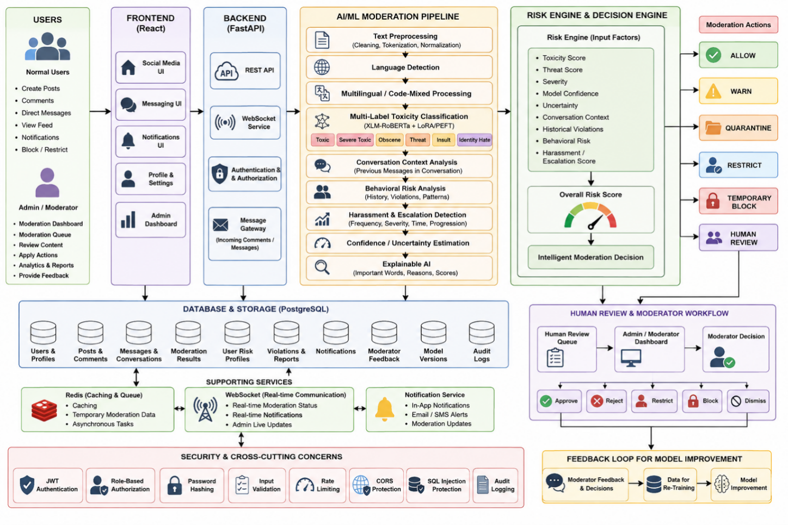

UML DIAGRAMS:

Use Case Diagram

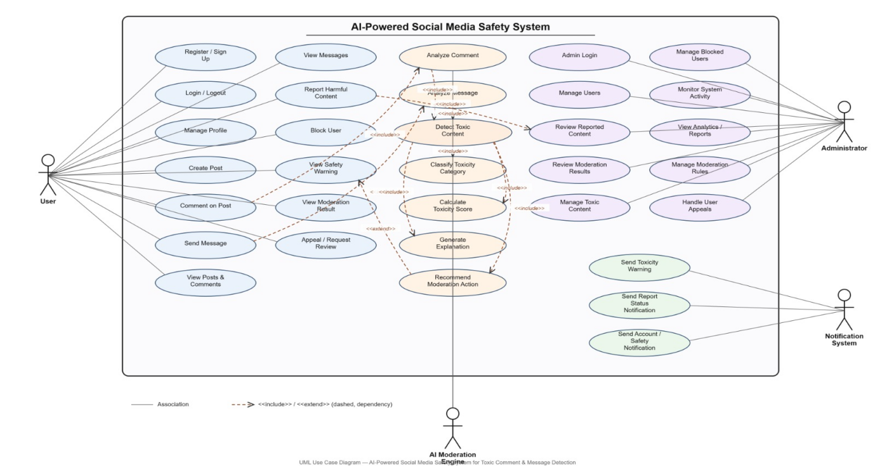

Class Diagram

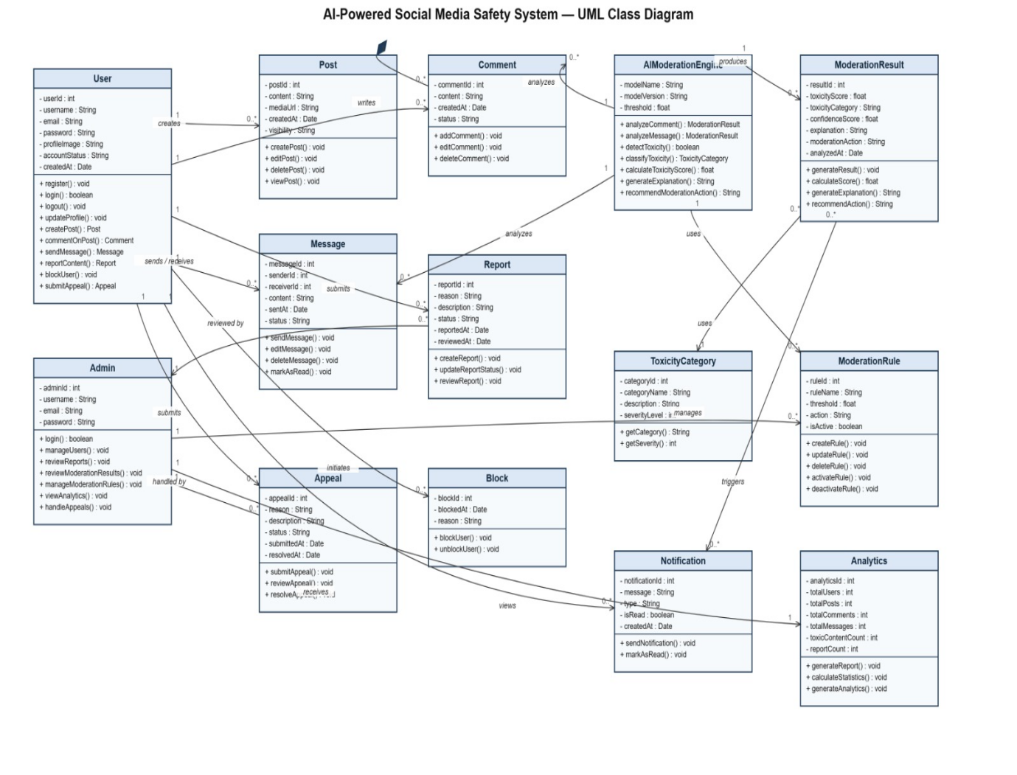

SUMMARY:

The proposed project, “An Explainable AI-Driven Framework for Toxic Content Detection and Intelligent Content Moderation,” aims to develop a proactive and intelligent system for improving safety on social media platforms. conventional systems that only classify content as toxic or non-toxic, the proposed framework analyzes toxicity, severity, threats, insults, conversation context, user behavior, repeated harassment, and escalation patterns.
The system uses multilingual and code-mixed text processing and an advanced XLM-RoBERTa with LoRA/PEFT model for multi-label toxic content classification. A Risk Engine combines the AI predictions with contextual and behavioral information to calculate an overall risk score. Based on this risk, the system can allow, warn, quarantine, restrict, temporarily block, or send content for human review.
A key feature of the project is Explainable AI, which provides understandable reasons and important behind moderation decisions. The system also incorporates uncertainty estimation, adversarial robustness testing, moderator feedback, notifications, and moderation history.
Overall, the project combines AI-based detection, context analysis, behavioral risk assessment, Explainable AI, and adaptive moderation into a single framework to provide more transparent, proactive, and effective social media content moderation.

REFERENCES:

- C. Clarke, M. Hall, G. Mittal, Y. Yu, S. Sajeev, J. Mars, and M. Chen, “Rule by Example: Harnessing Logical Rules for Explainable Hate Speech Detection,” Proc. 61st Annu. Meeting Assoc. Comput. Linguistics (ACL), pp. 364–376, 2023, doi: 10.18653/v1/2023.acl-long.22.

- Y. Yang, J. Kim, Y. Kim, N. Ho, J. Thorne, and S.-Y. Yun, “HARE: Explainable Hate Speech Detection with Step-by-Step Reasoning,” Findings Assoc. Comput. Linguistics: EMNLP 2023, pp. 5490–5505, 2023, doi: 10.18653/v1/2023.findings-emnlp.365.

- N. K. Singh, P. Singh, P. Das, and S. Chand, “XRBi-GAC: A Hybrid Deep Learning Framework for Multilingual Toxicity Detection,” J. Intell. Fuzzy Syst., vol. 45, no. 1, pp. 1409–1421, 2023, doi: 10.3233/JIFS-224536.

- M. Ye, K. Sikka, K. Atwell, S. Hassan, A. Divakaran, and M. Alikhani, “Multilingual Content Moderation: A Case Study on Reddit,” Proc. 17th Conf. Eur. Chapter Assoc. Comput. Linguistics (EACL), pp. 3828–3844, 2023.

- Y. Zhang, S. Nanduri, L. Jiang, T. Wu, and M. Sap, “BiasX: ‘Thinking Slow’ in Toxic Content Moderation with Explanations of Implied Social Biases,” Proc. 2023 Conf. Empirical Methods Natural Language Processing (EMNLP), pp. 4920–4932, 2023, doi: 10.18653/v1/2023.emnlp-main.300.

- T. Nguyen, J. Xu, A. Roy, H. Daumé III, and M. Carpuat, “Towards Conceptualization of ‘Fair Explanation’: Disparate Impacts of Anti-Asian Hate Speech Explanations on Content Moderators,” Proc. 2023 Conf. Empirical Methods Natural Language Processing (EMNLP), pp. 9696–9717, 2023, doi: 10.18653/v1/2023.emnlp-main.602.

- A. Calabrese, L. Neves, N. Shah, M. Bos, B. Ross, M. Lapata, and F. Barbieri, “Explainability and Hate Speech: Structured Explanations Make Social Media Moderators Faster,” Proc. 62nd Annu. Meeting Assoc. Comput. Linguistics (ACL), vol. 2, pp. 398–408, 2024, doi: 10.18653/v1/2024.acl-short.38.

- J. Zheng, X. Liu, M. Haque, X. Qian, G. Yang, and W. Yang, “HateModerate: Testing Hate Speech Detectors against Content Moderation Policies,” Findings Assoc. Comput. Linguistics: NAACL 2024, pp. 2691–2710, 2024, doi: 10.18653/v1/2024.findings-naacl.172.

- Y. T. Cao, L.-F. Domingo, S. Gilbert, M. L. Mazurek, K. Shilton, and H. Daumé III, “Toxicity Detection is NOT all You Need: Measuring the Gaps to Supporting Volunteer Content Moderators through a User-Centric Method,” Proc. 2024 Conf. Empirical Methods Natural Language Processing (EMNLP), pp. 3567–3587, 2024, doi: 10.18653/v1/2024.emnlp-main.209.

- M. R. Costa-jussà, M. Coria Meglioli, P. Andrews, D. Dale, P. Hansanti, E. Kalbassi, A. Mourachko, C. Ropers, and C. Wood, “MuTox: Universal Multilingual Audio-based Toxicity Dataset and Zero-shot Detector,” Findings Assoc. Comput. Linguistics: ACL 2024, pp. 5725–5734, 2024, doi: 10.18653/v1/2024.findings-acl.340.

- M. S. Hee, S. Sharma, R. Cao, P. Nandi, P. Nakov, T. Chakraborty, and R. K.-W. Lee, “Recent Advances in Online Hate Speech Moderation: Multimodality and the Role of Large Models,” Findings Assoc. Comput. Linguistics: EMNLP 2024, pp. 4407–4419, 2024, doi: 10.18653/v1/2024.findings-emnlp.254.

- D. Kumar, Y. A. AbuHashem, and Z. Durumeric, “Watch Your Language: Investigating Content Moderation with Large Language Models,” Proc. Int. AAAI Conf. Web Social Media, vol. 18, pp. 865–878, 2024, doi: 10.1609/icwsm.v18i1.31358.

- J. Park, S. Jeong, S. Song, Y. Lee, and A. Oh, “LLM-C3MOD: A Human-LLM Collaborative System for Cross-Cultural Hate Speech Moderation,” Proc. 3rd Workshop Cross-Cultural Considerations NLP (C3NLP), pp. 71–88, 2025, doi: 10.18653/v1/2025.c3nlp-1.7.

- N. Fasching and Y. Lelkes, “Model-Dependent Moderation: Inconsistencies in Hate Speech Detection Across LLM-based Systems,” Findings Assoc. Comput. Linguistics: ACL 2025, pp. 22271–22285, 2025, doi: 10.18653/v1/2025.findings-acl.1144.

[15] T. Davidson, “Multimodal Large Language Models Can Make Context-Sensitive Hate Speech Evaluations Aligned with Human Judgement,” Nature Human Behaviour, vol. 10, pp. 514–530, 2026, doi: 10.1038/s41562-025-02360-w.

